Crypto Academy
Crypto Academy is a website that teaches people about crypto and blockchain technologies which are the new kid in the block of finance. As we know and Forsee crypto and blockchain is the future of finance and is already have its ripple effect across many industries from health to real estate as John Macaffe once said” You can’t stop things like Bitcoin they will be everywhere the world would have to readjust, and governments will have to readjust” this is the new currency of the internet.
OBJECTIVE
- Crypto academy is an educational website that aims to educate people about cryptocurrencies and web3 technologies ranging from blockchain to defi to smart contract and investing.
Goals
1.To provide education & awareness about cryptocurrencies
2.To promote safe usage of crypto helping users avoid losing money
3.To build trust in digital technologies and reduce fear of cryptocurrencies
4.To enhance skills development in digital finance skills and basic investment knowledge
Target Audience
- Students (Junior school to university)
- Age:15-25
  - Young Professionals (Age 25-34)
- Tech Enthusiasts/Developers (any age)
- People in Rural Areas
Technical aptitude
All of the target audience will need to understand how to use a smartphone, laptops or desktop computers. They shall have the skill of navigating through a website and browsers where the website will be hosted.

- Type of website
  - This is an educational website platform focused on cryptocurrency literacy providing financial information on crypto economics. It provides tutorial, information and content related to crypto.

- Information Design and Taxonomy
- Sitemap
    - Home
        - This is the first page the user interacts with when they visit the website it will contain the links to the curriculum, course quizzes, articles and Faqs.
    - Curriculum
        - This link will take the user to the curriculum page which has the learning pathways the user can take, showing beginner, intermediate and advanced learning pathways the user can select one to take and receive content as per the chosen pathways.
- Quizzes
  - This section will show quizzes to test the users progress and understanding looking at the learning pathway the user has chosen
  - Article
    - This section hosts several articles covering crypto related topics
    - FAQs
      - This section includes frequently asked questions about crypto

- Story Board flowchart
  - These is the visual representation of the site map

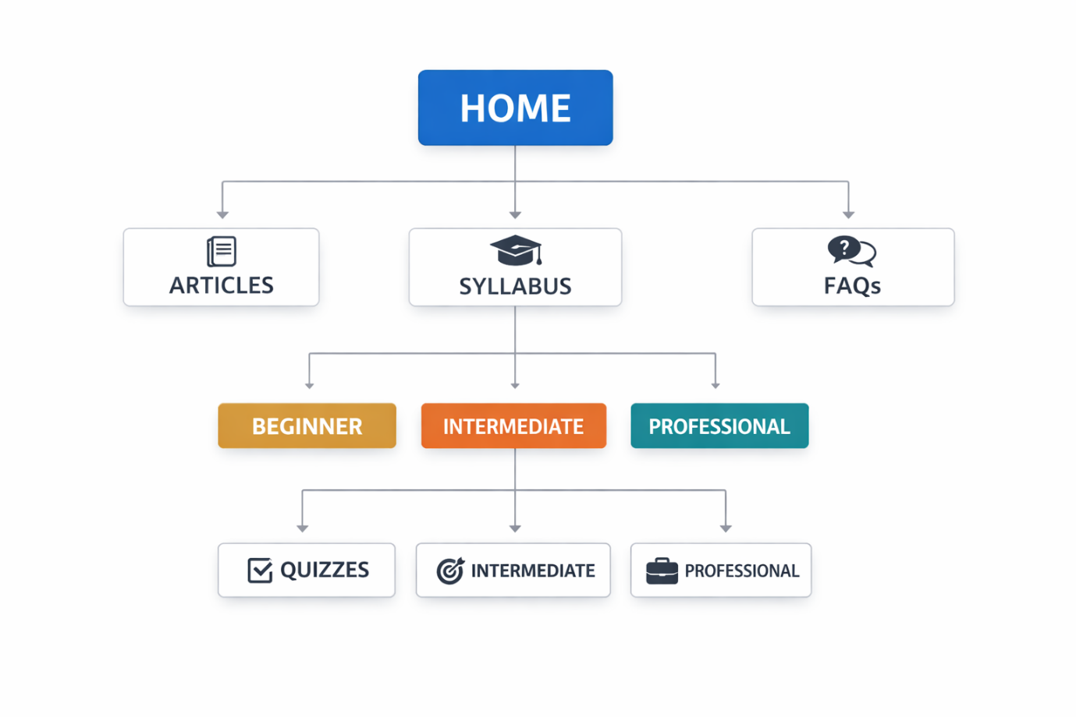

- Technical Brief
  - Planning
    - Microsoft word is where one can write documents so we found it ideal to use it for documentation as one can write and display images.

    - Canva is a popular, user-friendly online graphic design platform and app that allows individuals and teams to create professional-quality visuals without advanced design skills, so we decided to use to used for our mock up at crypto academy. And ExcaliDraw a free, open-source, web-based virtual whiteboard that allows users to sketch diagrams with a distinctive "hand-drawn" aesthetic for crypto academy we used this to draw our wireframes.
    - Edraw-max online for sitemaps
  - Construction and content development
    - Html is a markup structured language that we use to write the underlying code for a webpage. So i use html in writing the code for the crypto academy website which will be rendered and displayed by the web browser.
    - CSS stands for cascading style sheet which is used to add styling in a web browser. CSS will be used to style the website.
    - JavaScript is an interactive element used to create dynamic content in a website. JavaScript will be used to build quizzes and for interactiviness.
    - Bootstrap is an open-source toolkit that used to build mobile first website. Bootstrap will be used to build responsive website.
    - Vs code is integrated development environment where the entire code in html, JS, CSS and bootstrap will be written and tested.
    - GitHub is a version control software used for hosting content which allows other users to also make changes to your work. In our case GitHub will be used to host the website that we are developing and allows tutors to view the progress and the final product.
    - UNSPLASH is a platform where you can download images to use in the website. So for crypto academy most of the images used from this platform.
    - YouTube will be used to get videos that we embed to into the website that will explain some of the crypto content in crypto academy.

